**../../../../../../../Pictures/ARA/Pics/ARA%20LOGO/ARA%20master%20shield%20lo KENT ACTIVE ../../../../../../../Pictures/ARA/Pics/ARA%20LOGO/ARA%20master%20shield%20lo**

**THE NEWSLETTER OF THE KENT ACTIVE RETIREMENT ASSOCIATION**

**Volume Seven ∂ecember 2021 No. 86**

***Circulation: Ramming Speed***

***“Do not think of retirement as someone closing a door on a bright, and crowded street.***

***Think of it as someone opening the door to a beckoning and uncluttered world.”***

**John Hardiman** (Founder of the Association)

***From the Officers of the KentARA Committee***

**HAPPY CHRISTMAS & NEW YEAR**

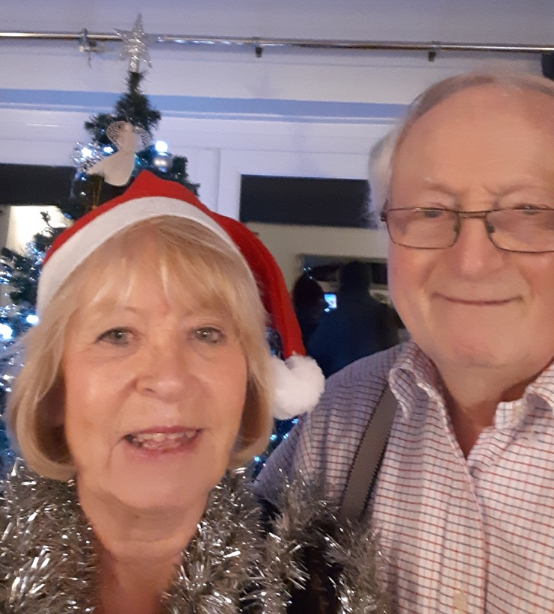

**Joan & Les**

**Dear Members,**

**I hope you are all well.**

**Let’s hope Omicron is a storm in a teacup, especially if we remain cautious, until it passes.**

**I have seen many of your photos on the KentARA website, and it looks like you have been trying to get back to normality whenever it has been possible.**

**KentARA had a stall at the Tracey Crouch *‘Roadshow’*, at Holmsdale School, Snodland. It was a great success with lots of interest shown towards our clubs, three of which exhibited there to engage with prospective new members.**

**We at KentARA are so looking forward to seeing as many as possible on the Cruise of the Fjords aboard *‘The Bolette’*, next September 2022, to celebrate Kentara’s 25th Anniversary.**

**There are still cabins available for this wonderful Cruise, so please contact**

**Fred Olsen direct, mentioning your Club, and the Kentara code, to take full advantage of the discounts available.**

**We are very sorry we had to cancel Gerald Benham’s *‘Tea Dance’* through lack of interest, but be assured it will go ahead next year.**

**Please keep in mind the safety lessons that we are all having to keep up with, and keep reminding ourselves of, due to these variants that are visiting us again.**

**Always wear your masks in public places, and wash your hands very thoroughly, it maybe tiresome but it will keep us alive.**

**I hope to visit as many Clubs as I possibly can next year - 2022, and see more new friends, as well as old ones.**

**I wish you all a very Happy Christmas and healthy New Year.**

**Much love to you all**

**Joan Rhodes X**

**KentARA Chairlady**

**(01732) 844 953** [**rhodjo@aol.com**](mailto:rhodjo@aol.com)

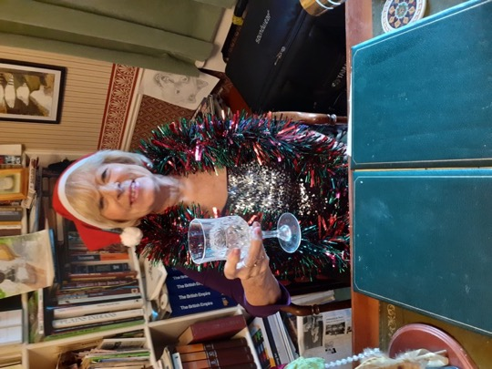

**Higham Active Retirement Association. HiARA**

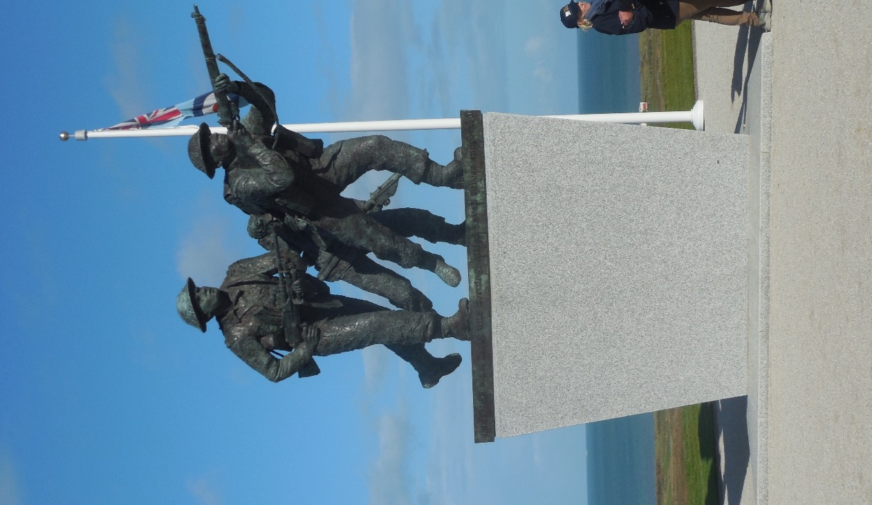

**On the weekend of 23rd October 2021, I had the privilege of travelling to the D-Day Beaches along with the Mayor of Gravesham, Councillor Lyn Milner, Staff, and students from St John’s School, Gravesend, with special guest veteran Royal Engineer, George Batts MBE.**

**George had campaigned for several years for a British Normandy Memorial, and it was a letter to the then Prime Minister, David Cameron, that turned the tide, and a donation of £20 million came along, with a further £10 million following through fund raising by the Normandy Trust.**

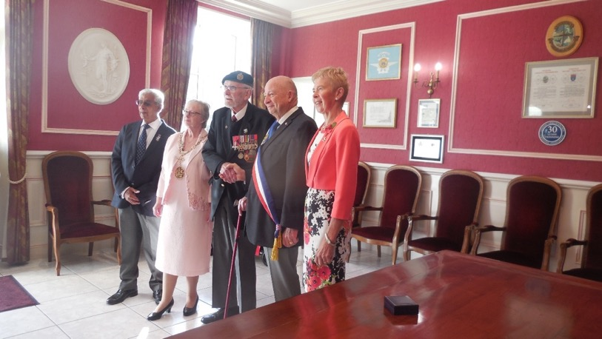

**Left to right, Gravesham Borough Councillor, Gurdip Bungar, Councillor Lyn Milner, Mayor of Gravesham, George Batts MBE, The Marie of Arromanche, Mrs Rosemary Dymond, Deputy Lord Lieutenant of Kent taken in the Civic Hall, Arromanche.**

**This was the first time, George had seen the completed project at Ver Sur Mer, nr Arromanche, Normandy.**

**Members of our club had agreed to the suggestion that I lay a wreath at the memorial, See the photographs below.**

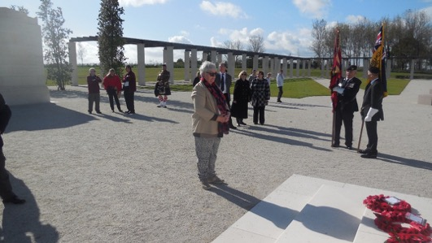

**We all had a very hectic but memorable weekend together and we also visited Pegasus Bridge. If you are ever in that region, it is well worth the visit.**

**There are 22,440 names inscribed on the columns.**

**Liz Jeffery, Chair, HiARA**

**Tracey Crouch *‘Roadshow’*, at Holmsdale School, Snodland** 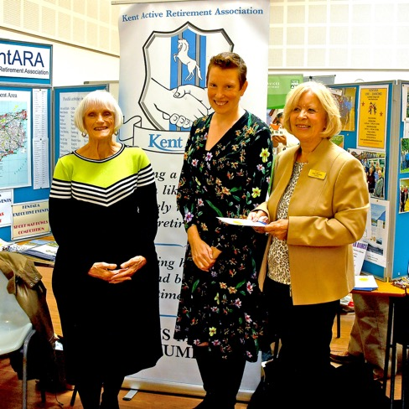

**Left to Right. Lin Martin KentAra General Secretary. Tracey Crouch MP Chavham & Alesford. Joan Rhodes. The Boss.**

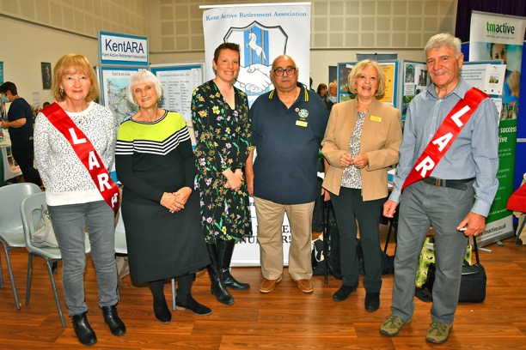

**Lar Lar Land**

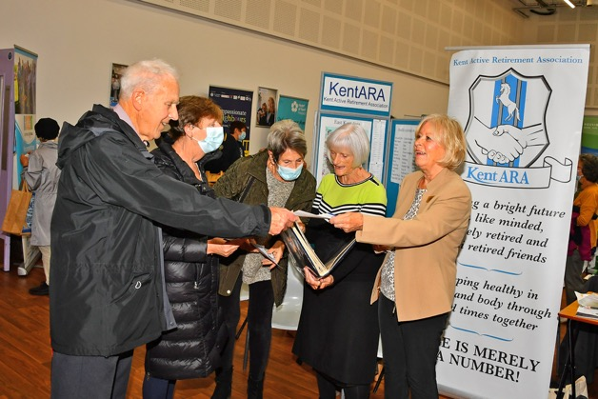

**Joan says, “Take it”, Man says, “Have it”…**

***Provisional***

**DATES FOR THE DIARY**

**2022**

* **‘KentARA Quiz’ at Ditton**

**Thursday 23rd March 2022**

**(details to be confirmed)**

* **KentARA AGM at Ditton**

**Thursday 7th April 2022**

**10am Coffee / 11am Start**

* **Short Mat Bowls at Ditton**

**25th August 2022**

**(details to be confirmed)**

* **KentARA 7 Night Cruise Norway**

**All aboard the ‘The Bolette’**

**14th September 2022**

* **Race Afternoon at Ditton**

**20th October 2022**

**(details to be confirmed)**

* **Rochester Cathedral**

**KentARA Thanksgiving Service 11am**

**Thursday 27th October 2022**

**(details to be confirmed - God Welling)**

* **KentARA Christmas Concert at Ditton**

**Thursday 8th December**

**(Camels park free. Details to be confirmed)**

**‘News from The Front’**

**The next edition of the Kent Active in 2022 will see a new editor take over from ‘Wishy Washy’, who is stepping down after a hard year confined to his desk behind the KentARA typewriter.**

**Wishy says, “It’s been a year of ups and downs, but the final straw came when one of the wheels of my office chair broke, leaving the whole thing pivoted forward, wedged into the carpet, and impossible to swivel on. Unfortunately, if I can’t swivel, I can’t think to type.”**

**Due to this lucky break, our new editor stepped forward, and we welcome Mr William Wormshill from WormARA who will cast the new Kent Active in 2022.**

**In the meantime, please send your Club pictures, and news stories to the KentARA website via our Webmistress Pat Cox at pmc1948@live.co.uk**

**The KentARA website.** [**https://kentara.weebly.com/photos.html**](https://kentara.weebly.com/photos.html)

**Please ensure that all pictures you send have the permission of those who appear in them, to be published.**

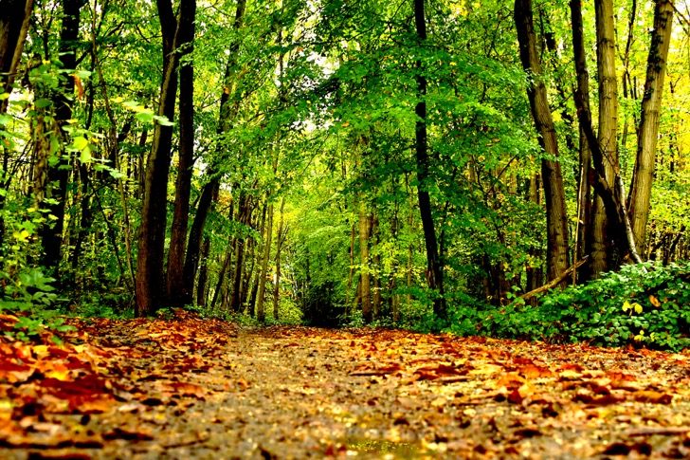

**Photograph by Graham Pover. Graham can be contacted at** [**gpoverphotography@btinternet.com**](mailto:gpoverphotography@btinternet.com)

**The Nativity**

**Luke Chapter 2 v4-20 *KJB***

**4And Joseph … went up from Galilee, out of the city of Nazareth, into Judaea, unto the city of David, which is called Bethlehem; (because he was of the house and lineage of David:)**

**5…with Mary his espoused wife, being great with child.**

**6And so it was, that, while they were there, the days were accomplished that she should be delivered.**

**7And she brought forth her firstborn son, and wrapped him in swaddling clothes, and laid him in a manger; because there was no room for them in the inn.**

**8And there were in the same country shepherds abiding in the field, keeping watch over their flock by night.**

**9And, lo, the angel of the Lord came upon them, and the glory of the Lord shone round about them: and they were sore afraid.**

**10And the angel said unto them, Fear not: for, behold, I bring you good tidings of great joy, which shall be to all people.**

**11For unto you is born this day in the city of David a Saviour, which is Christ the Lord.**

**12And this shall be a sign unto you; Ye shall find the babe wrapped in swaddling clothes, lying in a manger.**

**13And suddenly there was with the angel a multitude of the heavenly host praising God, and saying,**

**14Glory to God in the highest, and on earth peace, good will toward men.**

**15And it came to pass, as the angels were gone away from them into heaven, the shepherds said one to another, let us now go even unto Bethlehem, and see this thing which is come to pass, which the Lord hath made known unto us.**

**16And they came with haste, and found Mary, and Joseph, and the babe lying in a manger.**

**17And when they had seen it, they made known abroad the saying which was told them concerning this child.**

**18And all they that heard it wondered at those things which were told them by the shepherds.**

**19But Mary kept all these things, and pondered them in her heart.**

**20And the shepherds returned, glorifying and praising God for all the things that they had heard and seen, as it was told unto them.**